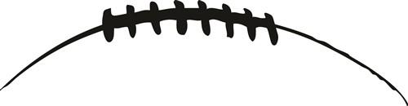
2024 MEMORIAL FOOTBALL CAMP

OCC Champs  2016, 2017, 2018, 2023 |  | State Playoffs  2016, 2017, 2018, 2020, 2021, 2022, 2023

INSTALLATION CAMP (JUNE 11-13)

Coach LoParo and The Bradley & Memorial Football Staffs would like to invite all incoming Memorial 7th & 8th graders to our installation camp that will run in conjunction with our youth camp. The camp will allow our HS & MS coaches to teach position specific skills and install plays for the upcoming season. This is a great opportunity for our players to be exposed to our systems and coaching styles. The camp will also feature a weight room introduction, competitions, a T-shirt and awards. The opinions, products, activities and/or services of this organization are neither sponsored nor endorsed by the Hilliard City School District.

INFORMATION
WHO? Memorial Players Entering 7th & 8th Grade
WHAT? 3-Day Football Installation Camp
WHEN? June 11th, 12th, & 13th (9:00am-Noon)
WHERE? Hilliard Bradley High School Stadium
COST: FREE
CONTACT: Please Direct Any Questions To:
Mike LoParo, michael_loparo@hboe.org , Head Coach
Justin Lemmermen, justin_lemmermen@hboe.org , Memorial Head Coach

CAMP NECESSITIES
Cleats or Tennis Shoes, Shorts & a Large Water Bottle.
*Water can be refilled at Camp

